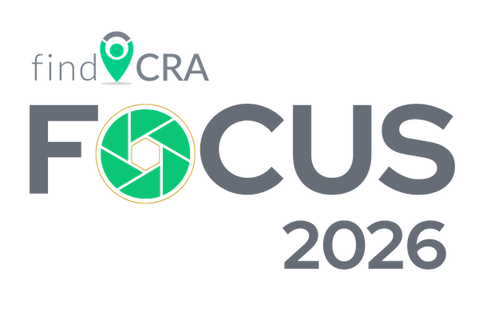
Conference Benefits & Justification Letter

Following, we’ve provided a template for a Conference Benefits & Justification Letter that you can utilize to share during your approval request to attend the 2026 conference. Feel free to edit or adjust the content of this letter as needed for your specific bank processes.

Hi, [Insert Manager’s Name],
I’d like to request approval to attend the findCRA FOCUS 2026 conference. This conference is a great opportunity to build my CRA expertise and knowledge through a virtual conference event. The conference will be held online on September 22 & 23, 2026.
What Will I Learn?
During the two-day virtual conference, CRA subject matter experts from findCRA and panelists who are other bankers, CRA practitioners, and industry thought leaders will provide practical, real world guidance on how best to manage CRA and ensure that we’re identifying the many ways we can earn CRA credit. findCRA FOCUS 2026 will provide in-depth and practical discussions on how to enhance our CRA program, analyze CRA data, and help prepare for our next exam.
There are a variety of sessions that will be dedicated to important CRA components, including:
- Maximizing community development credit through identifying and documenting activities
- Building responsive community partnerships
- Innovative CRA investment and financing
- Evaluating and monitoring lending performance
- Building performance context
- Assessing CRA performance to be exam ready
Why This Conference?
- It’s virtual! I won’t have to be out of the office to attend the conference and won’t lose days traveling back and forth. No airfare, no hotels, no travel meals. I can expand my CRA knowledge without leaving the office.

- It’s packed full of CRA knowledge! The general sessions will cover several CRA concepts that I need to know in my role and to support the bank’s CRA program. I’ll get to hear from subject matter experts at findCRA as well as other bankers and industry thought leaders about efficiently managing a strong and compliant CRA program and glean insights to implement for our CRA strategy.

- It’s practical knowledge! Rather than higher level discussions about CRA concepts and methodology, this conference is designed to provide actual case studies, real world examples, and practical guidance that I can take away and begin to implement immediately to support the bank’s success at our next CRA examination.

- It’s affordable! It’s only [$649 or $799] for me to attend the full two-day conference, including all general sessions, panel discussions, and even optional sessions. [As a findCRA customer, we even get a discounted rate of $649 to attend.]

If you’d like to see more about the findCRA FOCUS 2026, you can visit the conference website here. I appreciate your considering me to attend this virtual conference, as I think it will help me to build my CRA knowledge.

Sincerely,
[Your Name]
[Your Title]

